


Risol Tech Ltd
Addressable Fire Alarm Control System
The Intelligent Solution

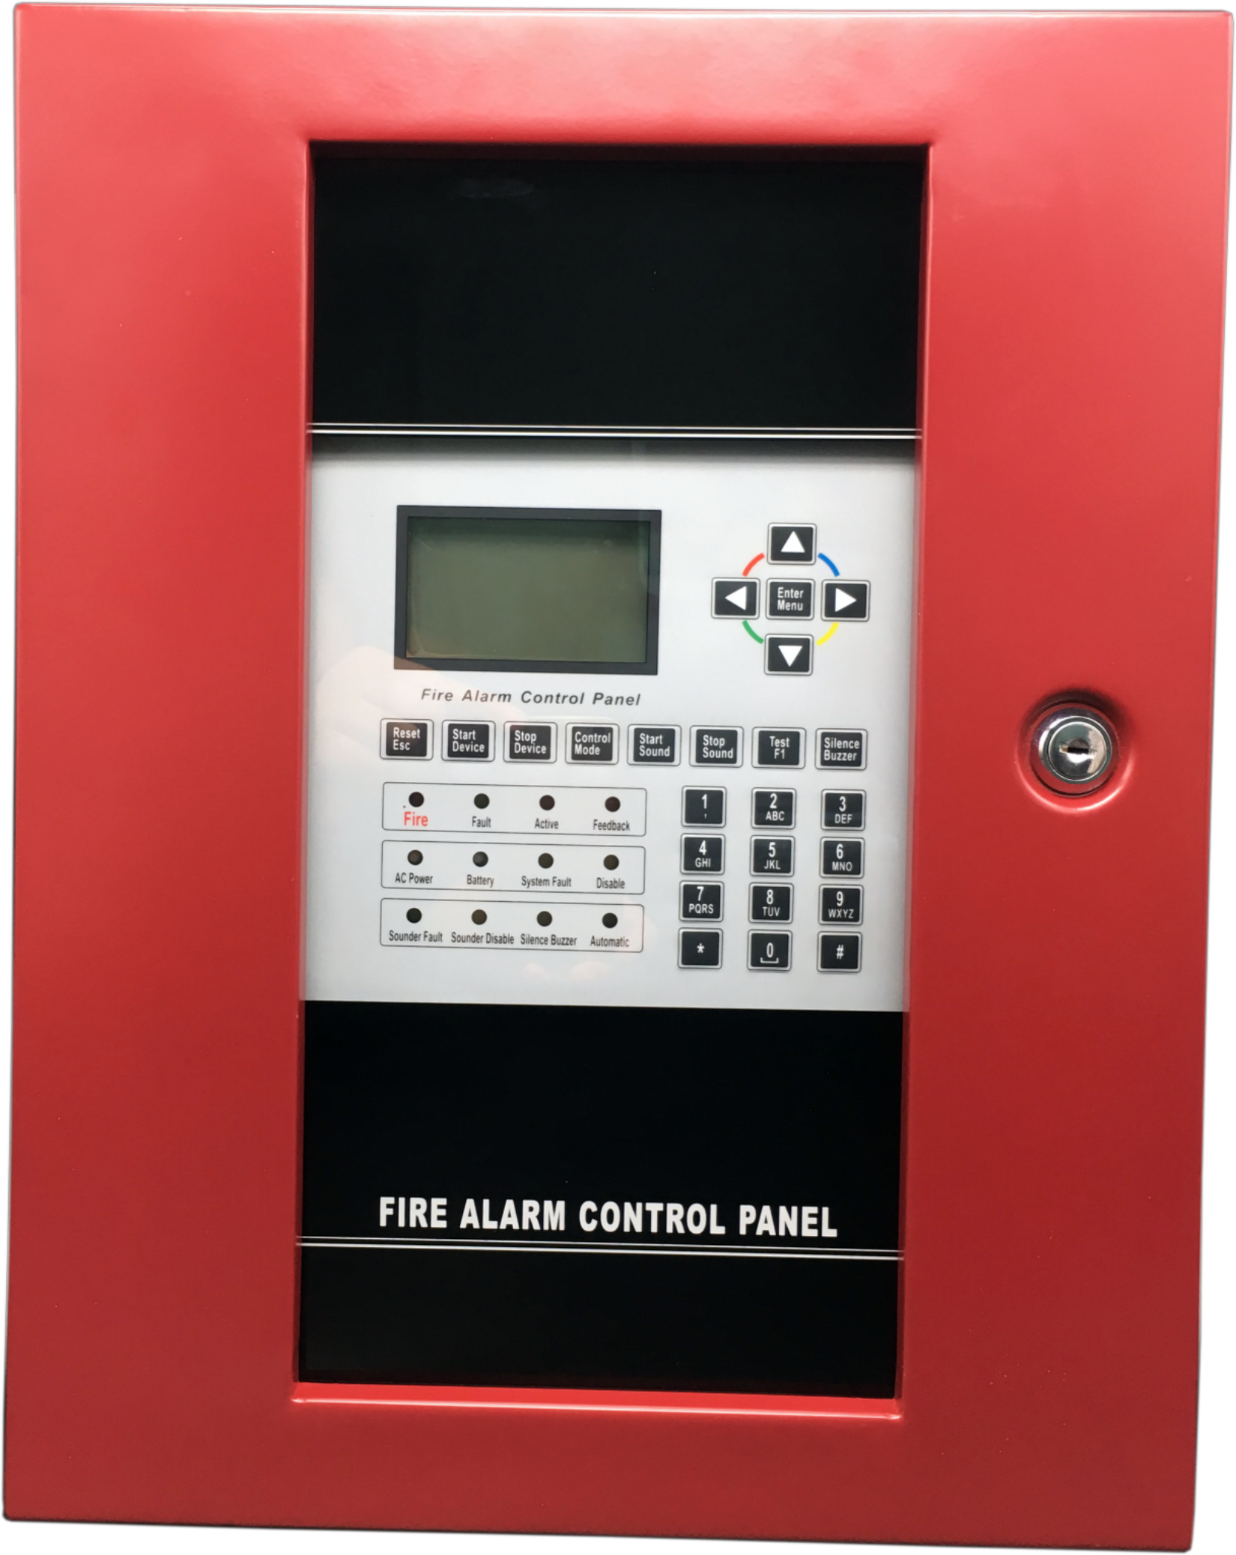

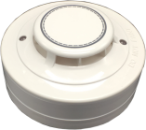
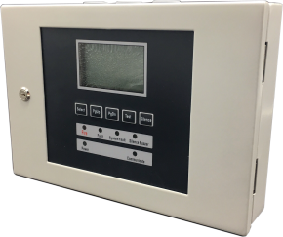

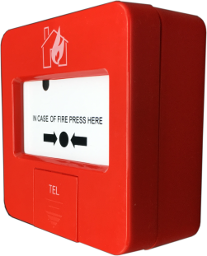

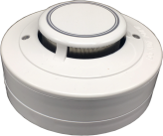
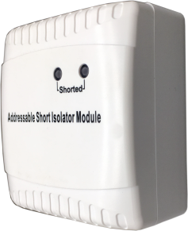
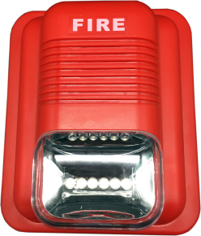

About Risol Tech

RiSol Tech Ltd is a security industry and a trusted provider of comprehensive fire system solutions around the world.
To ensure superior product quality,it has advanced manufacturing and inspection equipment and strong capabilities
in quality control and process management.
Professional high knowledge in fire alarm detection system,which allowed our factory specialize in OEM/ODM products range of fire alarm systems include:
- Intelligent addressable fire alarm system.
- Conventional fire alarm system.
- Intelligent wireless fire alarm system.
- Alone stand detectors.
- Extinghuishant control system.
RiSol Tech handles most processes of the manufacture, from design, to assembling, to QC, and package.
Our factory works with 4 SMD lines consist of the placement machines and reflow soldering, one wave soldering equipment. With capability of placing over 140,000 components per hours, the placement machines can offer the PCBA of 10,000 pcs detectors and 1,000 panel per day.We are especially proud of our fire testing room. It owns a number of testing equipment, such as UL-standard fire testing tunnel, EN- standard testing tunnel, temperature humidity test chamber, Long distance aging test board, Drop test machine,Key life test machine, etc.
This allows us to guarantee our products continue to meet the highest quality standards.
Our goal is, Providing the customer with Right Solution in fire alarm field.

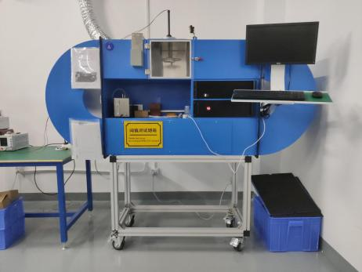
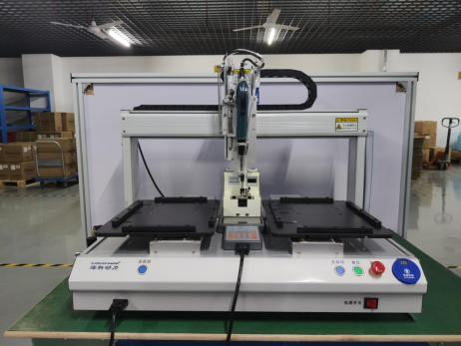
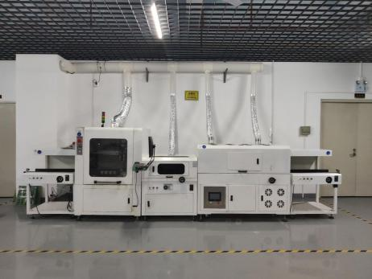

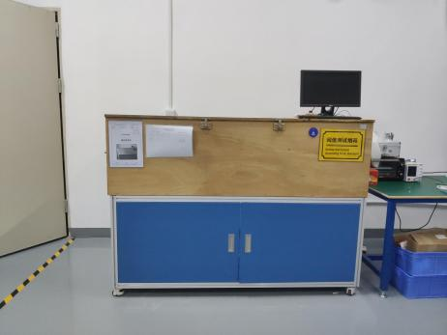
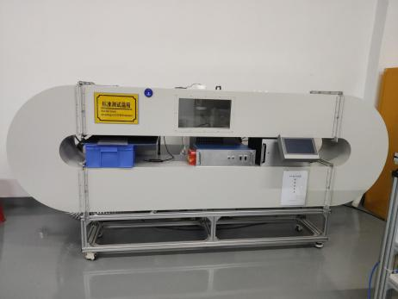
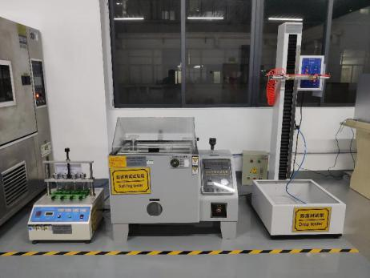

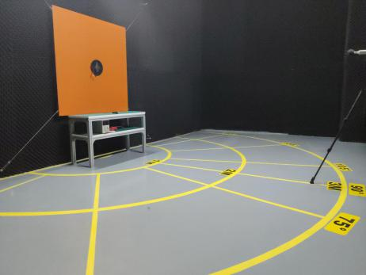
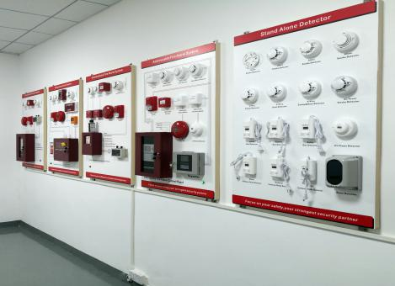
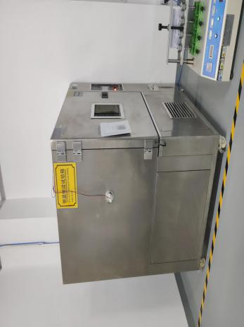

Intelligent Fire Alarm Panel

Overview
AFP900 Intelligent Fire Alarm Control Panel includes AFP901 and AFP901A. AFP901 is single loop with 125 points panel, possible to be expanded the single loop with 250 points version AFP901A. They are suitable for small buildings like office, restaurant, store, shop, etc., provide simple installation, operation, and easy maintenance.

Features
● Wide range power supply,90-270VAC, 50-60Hz..
● Capacity 125 addressable devices,Expanded to 250 addressable devices.
● Compatible with Risol intelligent and digital products.
● 8X16 characters LCD screen.
● Non-Volatile memory ensures the data does not loss even if power supply is accidentally removed.
● Dimension: 400mm*315mm*90mm.
● Weight:4.8kg(without batteries).
● Material of case: Metal.

Intelligent Addressable Smoke Detectors

Overview
ASD91 intelligent optical smoke detectors adopt the latest digital loop protocol, compatible with Risol intelligent fire alarm control panels. With digital communication, the detectors can raise fast alarm and much more control can be processed.It is designed based on light scattering technology with high performance chamber, suitable for detecting slow burning or smoldering fires
The detectors can be installed onto the common detector base DB90.
A remote indicator can be connected to each detector.

Features
● Electrically addressed, can be modified by programmer.
● Strong environmental adaptability due to drift compensation.
● Self-diagnostic.
● Fire LED allows 360°viewing.
● Communication:2 wires,Non-polarized.
● Dimension: Φ98*47 mm(with base).
●Weight:127g(with base).
●Material of case: ABS.

Intelligent Addressable Heat Detectors
Overview
AHD92 intelligent heat detectors adopt the latest digital loop protocol, compatible with Risol intelligent fire alarm control panels. With digital communication, the detectors can raise fast alarm and much more control can be processed.The AHD92 heat detector can provide FT & RR fire alarm by analyzing the temperature status by semiconductor heat sensor.
The detectors can be installed onto the common detector base DB90.
A remote indicator can be connected to each detector.

Features
● Electrically addressed, can be modified by programmer.
●Self-diagnostic.
●Rate-of-Rise thermal detector,A2R Class
● Fire LED allows 360°viewing.
● Communication:2 wires,Non-polarized.
● Dimension: Φ98*47 mm(with base).
●Weight:120g(with base).
●Material of case: ABS.

Addressable Manual Call Point

Overview
ACP94 manual call point adopts the latest digital loop protocol, compatible with Risol intelligent fire alarm control panels.
The manual call point is semi-flush mount type. A back box is supplied
for surface mounting.

Features
● Electrically addressed, can be modified by programmer.
● Re-settable (non-breaking glass) via special key.
● Dual activation indication.
● Friendly installation and test.
● Wiring before termination.
● Communication:2 wires,Non-polarized.
● Dimension: 85mm*85mm*38mm(with base).
●Weight:125g(with base).
●Material of case: ABS.



Addressable Sounder Strobe
Overview
ANS99 addressable sounder strobe can give audile and visual notification
signal when activated by Risol intelligent fire alarm control panel, to draw
attention or evacuate in case of emergency.

Features
● Electrically addressed, can be modified by programmer.
● Plexiglas lens, hi-light red, striking, long-life.
● Sound level over 85dB/3m.
● Strobe signal strength over 75cd.
● Two part plug in structure for easy installation.
● Communication:2 wires,Non-polarized.
● External power supply: 16 to 32VDC.
● Dimension: 134mm*115mm*50mm(with base).
● Weight:132g(with base).
● Material of case: ABS.

Addressable Loop Isolator Module

Features
● Electrically addressed, can be modified by programmer.
●Self-diagnostic
●LEDs for input and active indication
●Two part plug-in construction with base mounted termination allows easy installation and connection
● Intelligent interface can be addressed and plugged in to base at time of commissioning.
●Dimension: 85mm*85mm*40mm(with base).
●Weight:126g(with base).
●Material of case: ABS.

Overview
AIM95 Loop Isolator module is the protection facility for addressable loop, can isolate the shorted circuit from the complete loop to ensure normal operation of other parts and locate the isolated part. The isolator module is applicable to all kinds of loop fire alarm systems, suitable for Class A and
Class B.

Features
● Polarity-sensitive external connections.
● Delayed power-up to output end devices, avoids strong transient current when the load is heavy.
●Plug-in structure.
●Dimension: 85mm*85mm*40mm(with base).
●Weight:112g(with base).
●Material of case: ABS.

Addressable Input/Output Module

Overview
ARM96 input/output module is suitable to drive conventional notification devices or other power required equipment in 4-wire mode by external 24VDC power supplying, and also possible to provide dry contact output in loop powered mode. Maximum 2A output current can be controlled in
4-wire mode.This module also has acceptable functionality, for receiving
normally-open contact signal. For normally-open signal, the input cable can be monitored with EOLR.

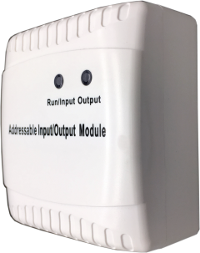

Features
● Electrically addressed, can be modified by programmer.
●Self-diagnostic
●LEDs for active and input indication.
●Two part plug-in construction with base mounted termination allows easy installation and connection.
● Intelligent interface can be addressed and plugged in to base at time of commissioning.
●Dimension: 85mm*85mm*40mm(with base).
●Weight:118g(with base).
●Material of case: ABS.

Addressable Input Module

Overview
ASM98 input module is loop powered, for receiving normally-open contact signal. For normally-open signal, the input cable can be monitored
with EOLR.

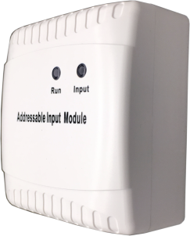

Features
● Electrically addressed, can be modified by programmer.
●Self-diagnostic.
●LEDs for run and input alarm indication.
●Two part plug-in construction with base mounted termination allows easy installation and connection.
● Intelligent interface can be addressed and plugged in to base at time of commissioning.
●Dimension: 85mm*85mm*40mm(with base).
●Weight:126g(with base).
●Material of case: ABS.

Addressable Interface Module

Overview
AZM97 interface module is designed to connect conventional detectors into addressable system, powered by external 24VDC. Maximum 30 conventional detectors can be connected to in each zone.
It is also useful to monitor equipment status with both active
and fault signals

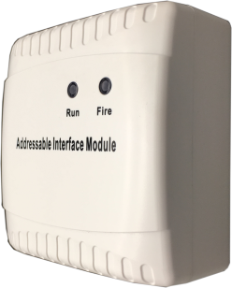

Features
●Electrically addressed, can be modified by programmer.
●Self-diagnostic
●LEDs for run and alarm indication
●Two part plug-in construction with base mounted termination allows easy installation and connection
● Intelligent interface can be addressed and plugged in to base at time of commissioning.
●Dimension: 85mm*85mm*40mm(with base).
●Weight:128g(with base).
●Material of case: ABS.

Hand Held Programmer

Overview
APT920 hand held programmer is the programming tool for all Risol addressable devices and some of conventional devices. It is also the tool to set sensitivities, working modes and other parameters.

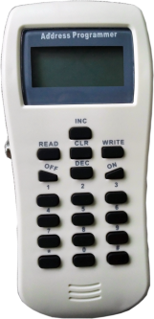

Features
●Hand held unit, portable tool
●Convenience operation
●Quadruple digit alphanumeric LCD display
●Low-consumption hibernation and power saving function
●Low battery indication
●Dimension:164mm*77mm*26mm.
●Weight:240g（with barreries,4*1.5V AA size batteries）.
●Material of case: ABS.

Repeater Panel

Overview
ARP910 repeater panel is a remote indication unit of Risol addressable system. In case of fire, the repeater panel will display the fire type, time and location details together with sound for local notification. This addressable repeater is possible to be connected with Risol addressable panels through RS485 links or addressable loop.

Features
●LCD display with backlight
●Compatible with all Risol intelligent panels
●Mute and lamp test
●Electrically addressing
●Dimension:250mm*175mm*51mm.
●Weight:1.5kg.
●Material of case: Metal.

System Application Diagram

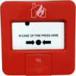
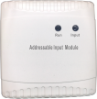
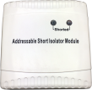
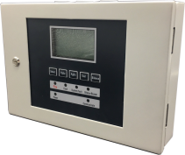
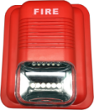
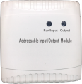
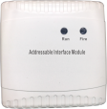
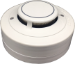
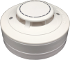
ARM96
ANS99
ASD91
ACP94
AFP901/902
ARP910
AHD92
AIM95
ASM98
Normally-open signal
AZM97
Maximum 30 conventional detectors can be connected to in each zone.

Conventional detectors
Notification devices
Maximum 15 repeaters can be
connected to in each loop.

2 Wires of loop
2 Wires of External power supply

