


Risol Tech Ltd
Conventional Fire Alarm Control System
The Intelligent Solution

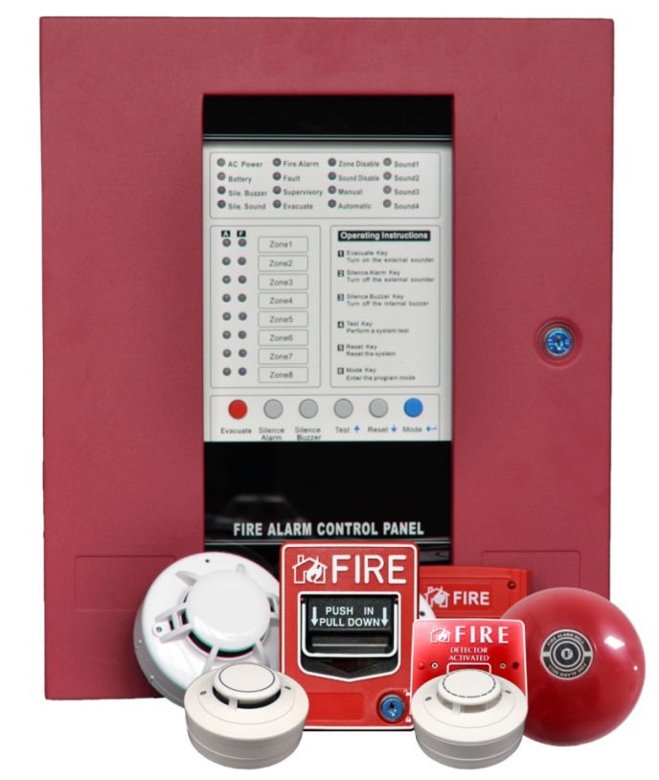

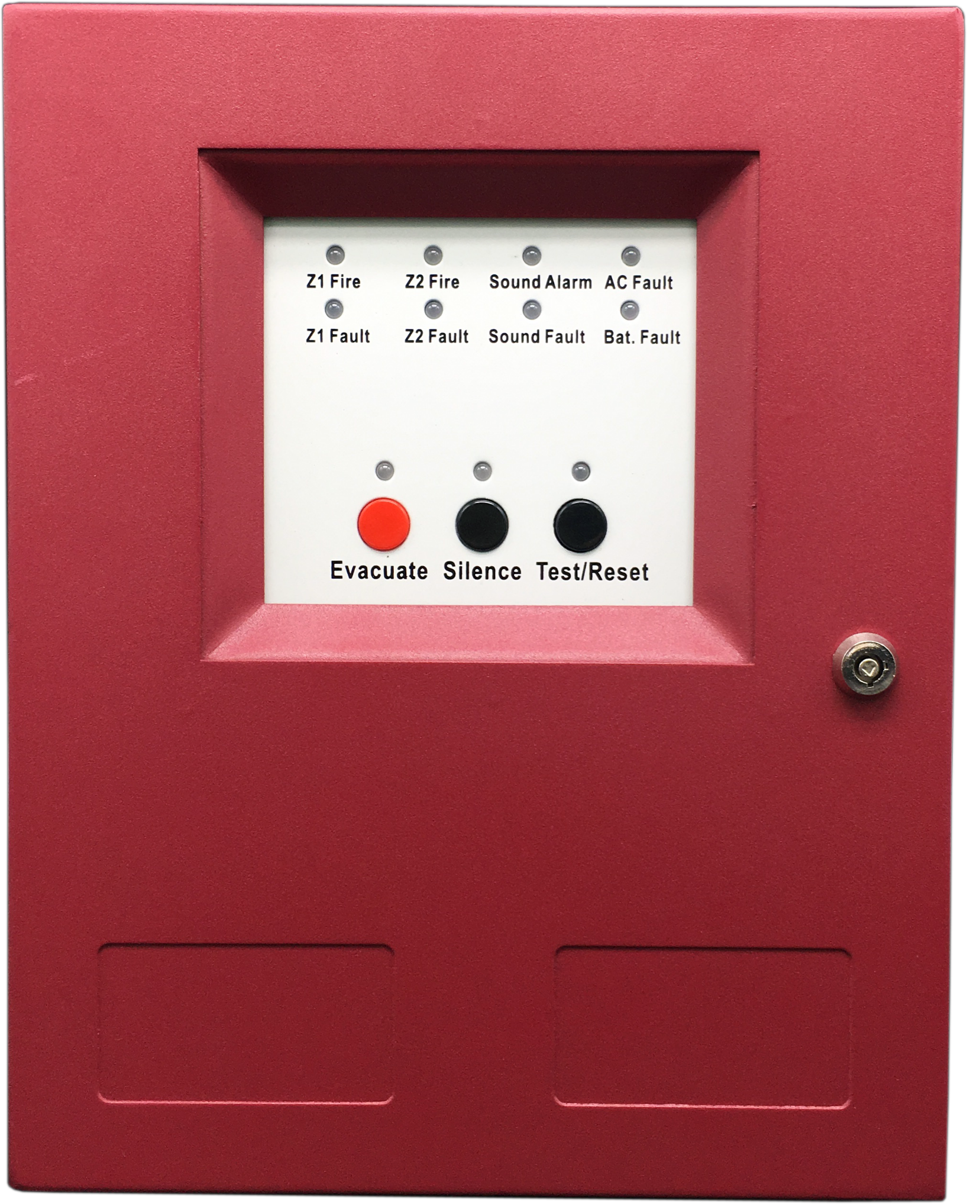

About US

Risol Tech Ltd is a security industry and a trusted provider of comprehensive fire system solutions around the world.
To ensure superior product quality,it has advanced manufacturing and inspection equipment and strong capabilities
in quality control and process management.
Professional high knowledge in fire alarm detection system,which allowed our factory specialize in OEM/ODM products range of fire alarm systems include:
- Intelligent addressable fire alarm system.
- Conventional fire alarm system.
- Intelligent wireless fire alarm system.
- Alone stand detectors.
- Extinghuishant control system.
Risol Tech handles most processes of the manufacture, from design, to assembling, to QC, and package.
Our factory works with 4 SMD lines consist of the placement machines and reflow soldering, one wave soldering equipment. With capability of placing over 140,000 components per hours, the placement machines can offer the PCBA of 10,000 pcs detectors and 1,000 panel per day.We are especially proud of our fire testing room. It owns a number of testing equipment, such as UL-standard fire testing tunnel, EN- standard testing tunnel, temperature humidity test chamber, Long distance aging test board, Drop test machine,Key life test machine, etc.
This allows us to guarantee our products continue to meet the highest quality standards.
Our goal is, Providing the customer with Right Solution in fire alarm field.

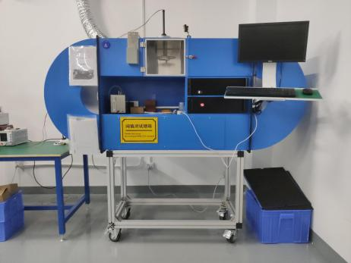
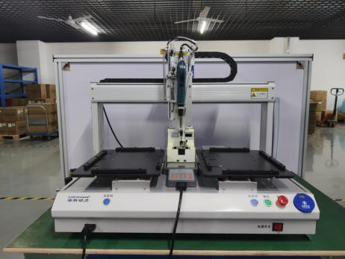
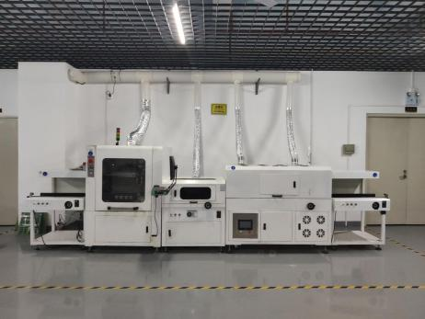

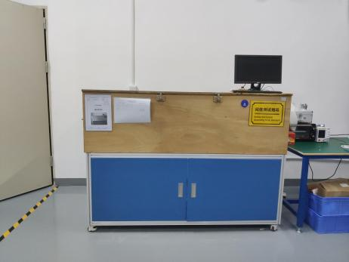
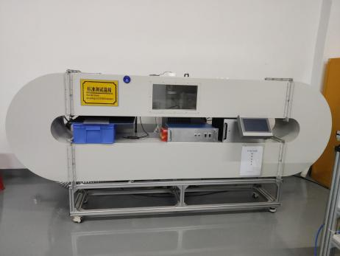
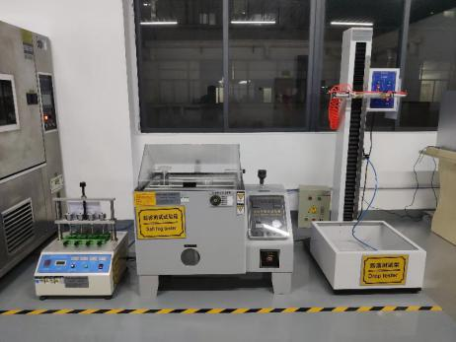

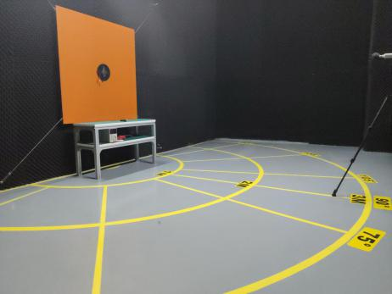
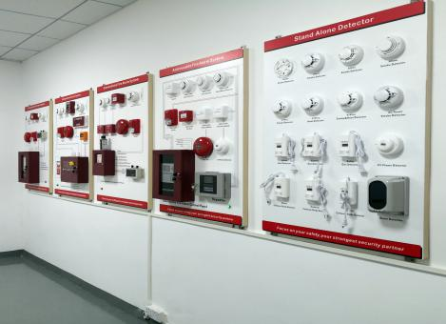
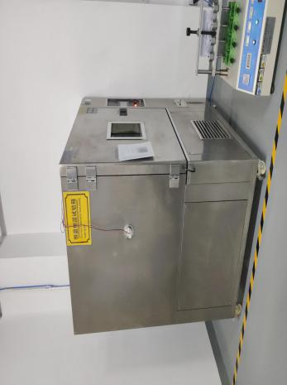

Features
● Electrically addressed, can be modified by programmer.
●Self-diagnostic
●LEDs for input and active indication
●Two part plug-in construction with base mounted termination allows easy installation and connection
● Intelligent interface can be addressed and plugged in to base at time of commissioning.
●Dimension: 85mm*85mm*40mm(with base).
●Weight:126g(with base).
●Material of case: ABS.

Conventional Fire Alarm Control Panel

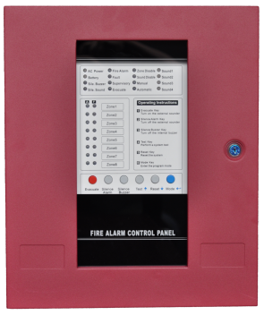

Overview
The CK1000 Series conventional fire alarm control panel is 24 volt, 2 to 16 zones, class B, conventional Fire Alarm Control Panel.
Designed exclusively to meet the latest market requirements and future ULC codes, the highly cost-effective Series can be used in a variety of low- to mid-sized applications.
The panel uses conventional input devices.The panel accepts water flow devices, two-wire smoke or heat detectors, four-wire smoke or heat detectors,call points and other normally-open contact devices. Outputs include four Notification Appliance Circuits(NAC, SOUND1-4), three standard Form-A relays (alarm, trouble and supervisory) and an EIA-485 port to interface with repeaters.The panel is field programmable via the panel keypad. It also supervises all wiring, AC voltage and battery level.

Features
※ 2,4,8,16 Class B Initiating Device Circuits (IDCS)
※ All zones accept conventional detectors and any normally open contact device
※ 1-4 Class B Notification Appliance Circuits (NACS)
※ One Form-A Alarm Relay
※ One Form-A Trouble Relay
※ One Form-A Supervisory Relay
※ 3.0 amps of system power
※ Sound output can be disabled.
※ Manual active sound output enabled.
※ Manual active sound output enabled.
※ Able to report short and broken circuit of detection zones.
※ Designed with standby batteries and space provision for two sealed lead-acid batteries.
※ Testing and disable functions.
※ Can connect maximum 32 repeater panels by RS485 communication port.
※ Max 30 conventional detectors in one zone.
※ Auto/Manual mode setting enable walk test.
※ Each Zone can be disabled
※ Panel Dimensions (mm)(L*W*D)：4 to 16 Zones: 370*440*100
※ Panel Weight [Without Batteries]：4 to16 Zones: 6.6kg /2 Zones: 2.2kg

Conventional Smoke Detector

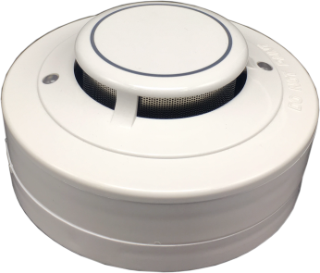

Features
※ Operating Voltage Range: 9 to 28 VDC Volts Non-polarized
※ Standby Current: ≤60µA@24VDC
※ Maximum Alarm Current: ≤30mA@24VDC (1K Ohm current-limiting resistance)
※ Operating Temperature Range:-10°C to 50°C (14°F to 122°F)
※ Smoke Alarm Sensitivity:0.15-0.3dB/m
※ Height: 48 mm installed in Base
※ Diameter：99 mm

Overview
This smoke detector can be used in all areas where photoelectric smoke detector is required. It is suitable for fires ranging from smoldering to flaming fires.
This smoke detector is designed to provide open area protection and to be used with any conventional fire alarm control panel. Two LED lights on each detector provide local 360° visible for indication of status. In the normal condition the LED lights flash red every 5 seconds. When the detector senses
smoke goes into pre-alarm sensitivity the LED lights will flash red every 1 second. When the detector goes into alarm the LED lights will light on red.
The alarm can be reseted only by a momentary power interruption.

Overview
This heat detector can be used in all areas where heat detector is required. It is suitable for fire ranging from smoldering to flaming fires.
This heat detector is designed to provide open area protection and to be used with any conventional fire alarm control panel. Two LED lights on each detector provide local 360° visible for indication of status. In the normal condition the LED lights flash red every 5 seconds. When the detector senses
temperature goes into pre-alarm sensitivity the LED lights will flash red every 1 second. When the detector senses heat goes into alarm the LED lights will light on red.
The alarm only can be reseted by a momentary power interruption.

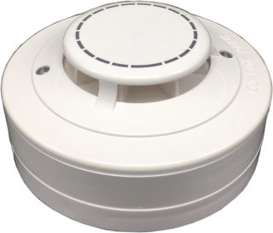

Features
※ Operating Voltage Range: 9 to 28 VDC Volts Non-polarized
※ Standby Current:≤60µA@24VDC
※ Maximum Alarm Current : ≤30mA@24VDC (1K Ohm current-limiting resistance)
※ Operating Temperature Range:-10°C to 50°C (14°F to 122°F)
※ Temperature Alarm Class: A2R, 57°C (135°F)
※ Height: 48 mm installed in Base
※ Diameter：99 mm

Overview
This Multi detector can be used in all areas where photoelectric smoke detector and heat detector is required. It is suitable for fires ranging from smoldering to flaming fires.
This detector is designed to provide open area protection and to be used with any conventional fire alarm control panel. Two LED lights on each detector provide local 360°visible for indication of status. In the normal condition the LED lights flash red every 5 seconds. When the detector senses smoke or heat goes into pre-alarm sensitivity the LED lights will flash red every 1 second. When the detector detect smoke or heat goes into alarm the LED lights will light on red.
The alarm can be reseted only by a momentary power interruption.

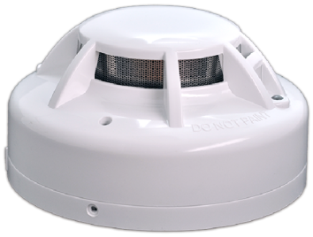
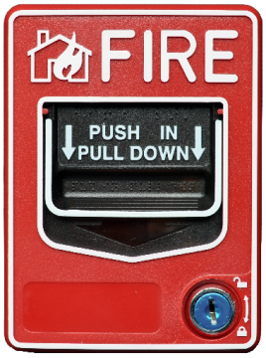

Conventional Multi Detector

Features
※ Operating Voltage Range: 9 to 28 VDC Volts Non-polarized
※ Standby Current: ≤60µA@24VDC
※ Maximum Alarm Current: ≤30mA@24VDC (1K Ohm current-limiting resistance)
※ Operating Temperature Range:-10°C to 50°C (14°F to 122°F)
※ Smoke Alarm Sensitivity:0.15-0.3dB/m
※ Temperature Alarm Class: A2R, 57°C (135°F)
※ Height: 55mm installed in Base
※ Diameter：103 mm
※ Weight：155g

Features
※ Operating Voltage Range：9 to 28VDC Volts
※ Maximum Alarm Current (LED on):≤50mA @ 24 VDC
※ Alarm Resistance：470ohm/1W
※ Operating Humidity Range：10% to 93% Relative Humidity,Non-condensing
※ Operating Temperature Range：-10°C to 50°C (14°F to 122°F)
※ Dimensions： Length 140mm, Width 105mm, Depth 45mm
※ Weight:Net Weight 220g

Overview
The conventional manual call point designed for conventional fire alarm system for reporting fire or emergency condition by its PUSH IN/PULL DOWN handle latches. It is only used with conventional fire alarm
control panel.

Conventional Manual Call Point

Conventional Sounder Strobe

Overview
The Sounder strobe is a kind of audible and visual alarm device installed in field, which can be activated by fire alarm control panel in fire control center or by manual call point installed in field. After activated,it will generate strong audible/audible and visual alarm signal to warn people in field.Three kind of sounds are optional.

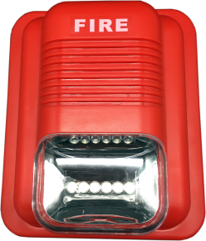

Features
※ Working voltage：9VDC-30VDC.
※ Alarm Current：≤ 50mA.
※ Ambient temperature：-10℃~+55℃.
※ Ambient humidity：≤95%RH.
※ Sound level of alarm：≥100dB.
※ Flash Intensity：≥75CD
※ Flash Period： <1S
※ Life of flash light：>40000times
※ Dimensions：133mm×115mm×50mm（ L ×W×D(With base)
※ Weight：141g

Overview
The conventional fire bell remains the most commonly used alarm for fire evacuation system, for wall applications, indoors.
The bell is designed to be used in 24 volt DC systems it meets the requirements of the EN54-3 standards

Conventional Fire Bell

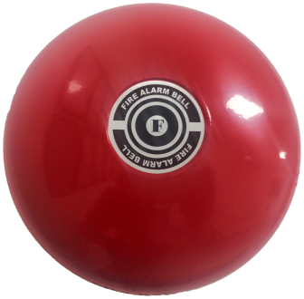

Features
※ Operating Voltage Range：DC24V
※ Alarm Current：Maximum 30 mA @ 24 VDC
※ Alarm Sound Intensity：Minimum 95dB
※ Operating Humidity Range：10% to 93% Relative Humidity,Non-condensing
※ Operating Temperature Range：-15°C to 60°C
※ Input terminal Wire Gauge：12 to 18 AWG
※ Dimensions：Diameter 150mm, Height 55mm
※ Weight：Net Weight 670g, Gross Weight 720g

Overview
The Repeater is compatible with all CK1000 Series control panels Repeaters are available with 16 zones with 24V powered (DC). Mains powered repeaters require only a two core data cable from the main control panel. 24V DC versions require an additional two cores for power either from the main panel or from another 24V DC source.
A mixture of Repeaters or Ancillary boards up to a maximum of 4 of each type can be connected to a control panel and each is allocated an address from 1 to 4 using a binary coded DIP switch.The total length of the data cable from the main panel to the last repeater must not exceed 1200 meters.

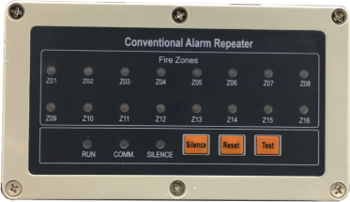

Conventional Fire Alarm Repeater

Features
※ Power supply: 16VDC to 30VDC
※ Current of power: Standby current: ≤15mA, Alarm current: ≤75mA
※ Relay contact capacity: 2A@24VDC
※ Buzzer level: 80dB@1m.
※ Protection level: IP55
※ Communication mode:RS485 (Wires: RVSP type,1.0 m㎡to 2.0m㎡)
※ Dimension of enclosure: 200mm(W)x91mm(H)x45mm(D)
※ Material of enclosure:ABS, White
※ Weight: 350g
※ Hole of enter wires: 1/2 inch(12mm)

Remote LED
Overview
The device is remote LED uses a state of-the-art designs.
This LED is designed to be used with detectors.
One 8mm LED provide local 360° visible alarm indication.
They flash with the same as detector that be connected.
Dual Standard Installation Size:
4 holes provid USA(83mm) and Europe(59mm) screws width
Material of case: ABS

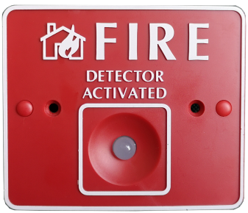

Conventional Fire Alarm system

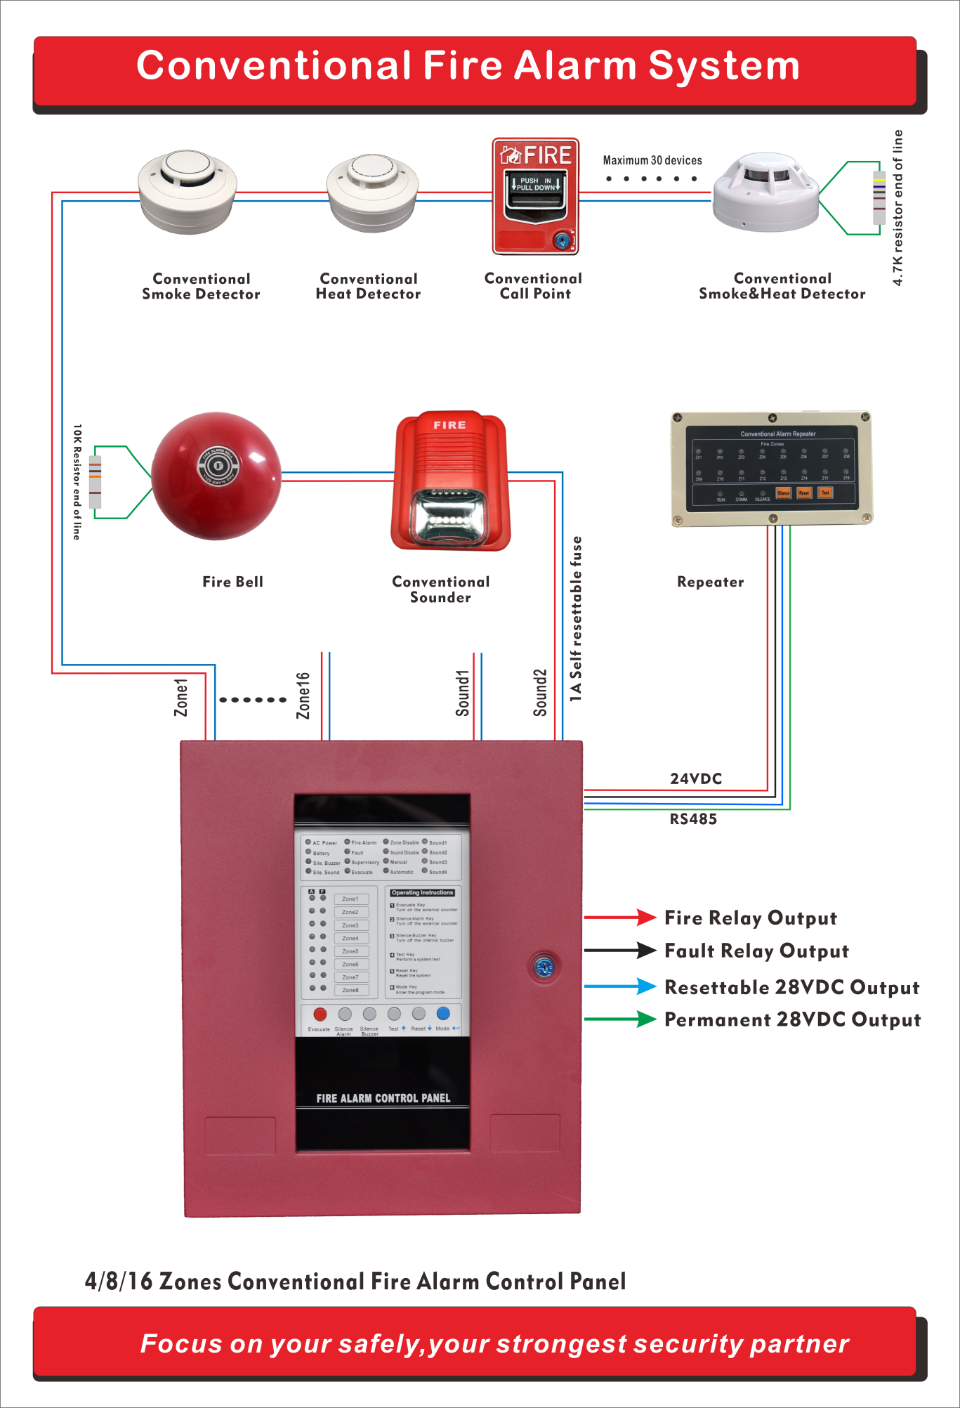

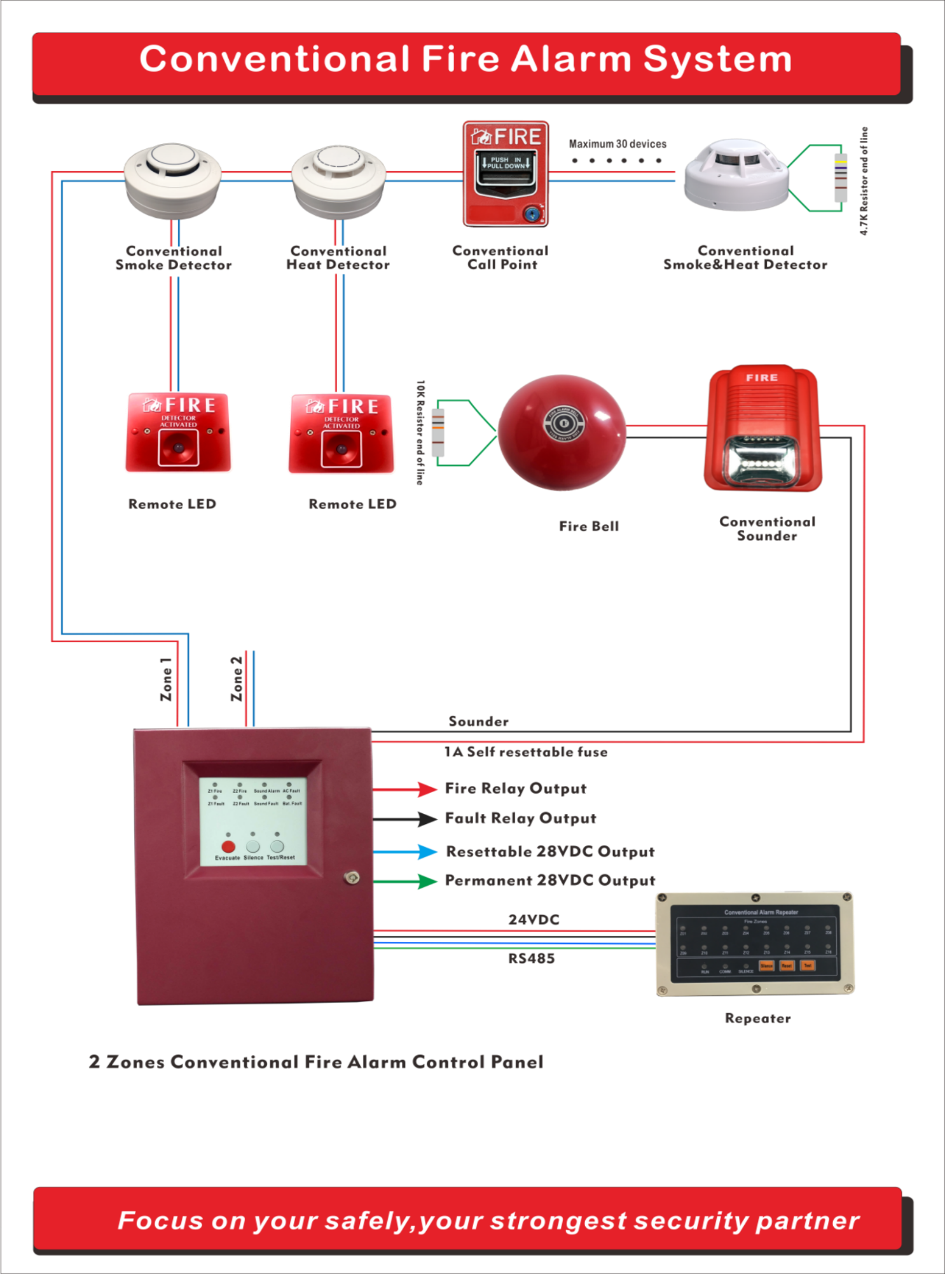

Conventional Fire Alarm system

Extinguishant Control Panel

Overview
The automatic extinguisher control panel is designed in accordance with European standards EN54-2 and EN54-4 Fire Detection and Fire Alarm System Control and Indicating Equipment and EN12094-1 Fixed firefighting system - Components for gas extinguishing systems - Part 1: Requirements and test methods for electrical automatic control and delay devices.
The control equipment is a combined fire alarm control panel and extinguishing system and has four detection zones, any or all of which are capable of contributing to the extinguishant release decision. Control panel has an integral, mains power battery charger and power supply designed in accordance with the requirements of EN54-4.

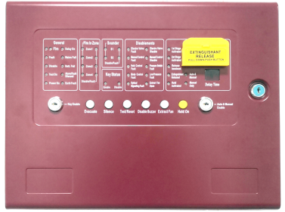

Features
※ Class B Initiating Device Circuits (IDCs)
※ 4 zones accept conventional detectors and any normally open contact device
※ 2 Class B Notification Appliance Circuits (NACs)
※ One Form-A Alarm Relay
※ One Form-A Fault Relay
※ Two Form-A Stage Relay
※ 3.0 amps of system power
※ Max 30 conventional detectors in one zone.
※ Each Zone can be disabled
※ Sound output can be disabled
※ Manual active sound output enabled
※ Can connect max 32 repeater panels by RS485 communication port
※ Panel Dimensions (mm) :383*295*87(L*W*D), grey and red color are optional.
※ Panel Weight [Without Batteries]：5.0kg

Manual Release Station

Overview
The manual release station is connected with fire fighting panel. There are three buttons on the station, one is START button, and another one is STOP button.
When the START button is pressed, you can press RESTORE button to restore the start button.

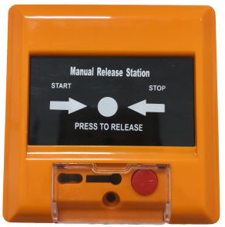

Features
※ Operating Voltage Range: 9 to 28 VDC Volts Non-polarized
※ Switch Contact Capacity：2Amp @24VDC
※ Maximum Alarm Current: ≤50mA @ 24 VDC
※ Operating Temperature Range: -10°C to 50°C (14°F to 122°F)
※ Panel of Press：Recoverable
※ Weight: 123g
※ Diameter：87*87*49(L*W*D）

Conventional Manual Call Point

Overview
The conventional manual call point is designed for conventional fire alarm system for reporting fire or emergency condition by its PUSH IN/PULL DOWN handle latches. It is only used with conventional fire alarm
control panel.

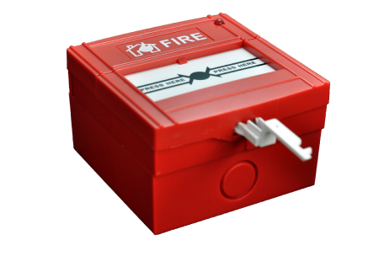

Features
※ Operating Voltage Range：9 to 28VDC Volts
※ Maximum Alarm Current (LED on): ≤50mA @ 24 VDC
※ Alarm Resistance：470ohm/1W
※ Operating Humidity Range：10% to 93% Relative Humidity,Non-condensing
※ Operating Temperature Range：-10°C to 50°C (14°F to 122°F)
※ Dimensions: Length 86mm, Width 86mm, Depth 57mm
※ Weight: Net Weight 158g

Release Warning Signage

Overview
The release warning signage is installed outside the gas protection site. When the gas is released it warns the personnel not to enter the air release protection
area.

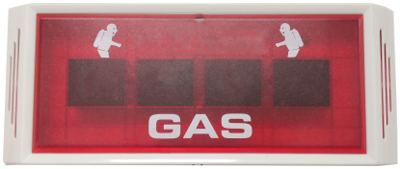

Features
※ Operating Voltage Range: 9 to 28 VDC Volts Non-polarized
※ Flash Intensity: >75CD
※ Maximum Alarm Current: ≤90mA @ 30 VDC
※ Operating Humidity Range: 10% to 93% Relative Humidity, Non-condensing
※ Operating Temperature Range: -10°C to 50°C (14°F to 122°F)
※ Flash Period: 1.5 Second
※ Material: ABS
※ Diameter: 295*120*28(L*W*D)
※ Weight: 293g

Maintenance Switch
Overview
This maintenance panel is a key switch, which disconnects actuation circuits in the system to prevent accidental discharge during maintenance
operations.
This panel is also available with the key removable in both the “SYSTEM ARMED” and the “SYSTEM INACTIVE” positions.

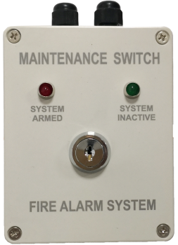

Features
※ Operating Voltage Range: 9 to 28 VDC Volts Non-polarized
※ Switch Contact Capacity: 5Amp @30VDC
※ Maximum Alarm Current : ≤20mA @ 30 VDC
※ Operating Humidity Range: 10% to 93% Relative Humidity, Non-condensing
※ Protection level: IP65
※ Operating Temperature Range: -10°C to 50°C (14°F to 122°F)
※ Material: ABS
※ Dimensions(MM): 115*90*54(L*W*D)
※ Weight: 237g

Schematic Diagram of Extinguishant Control System

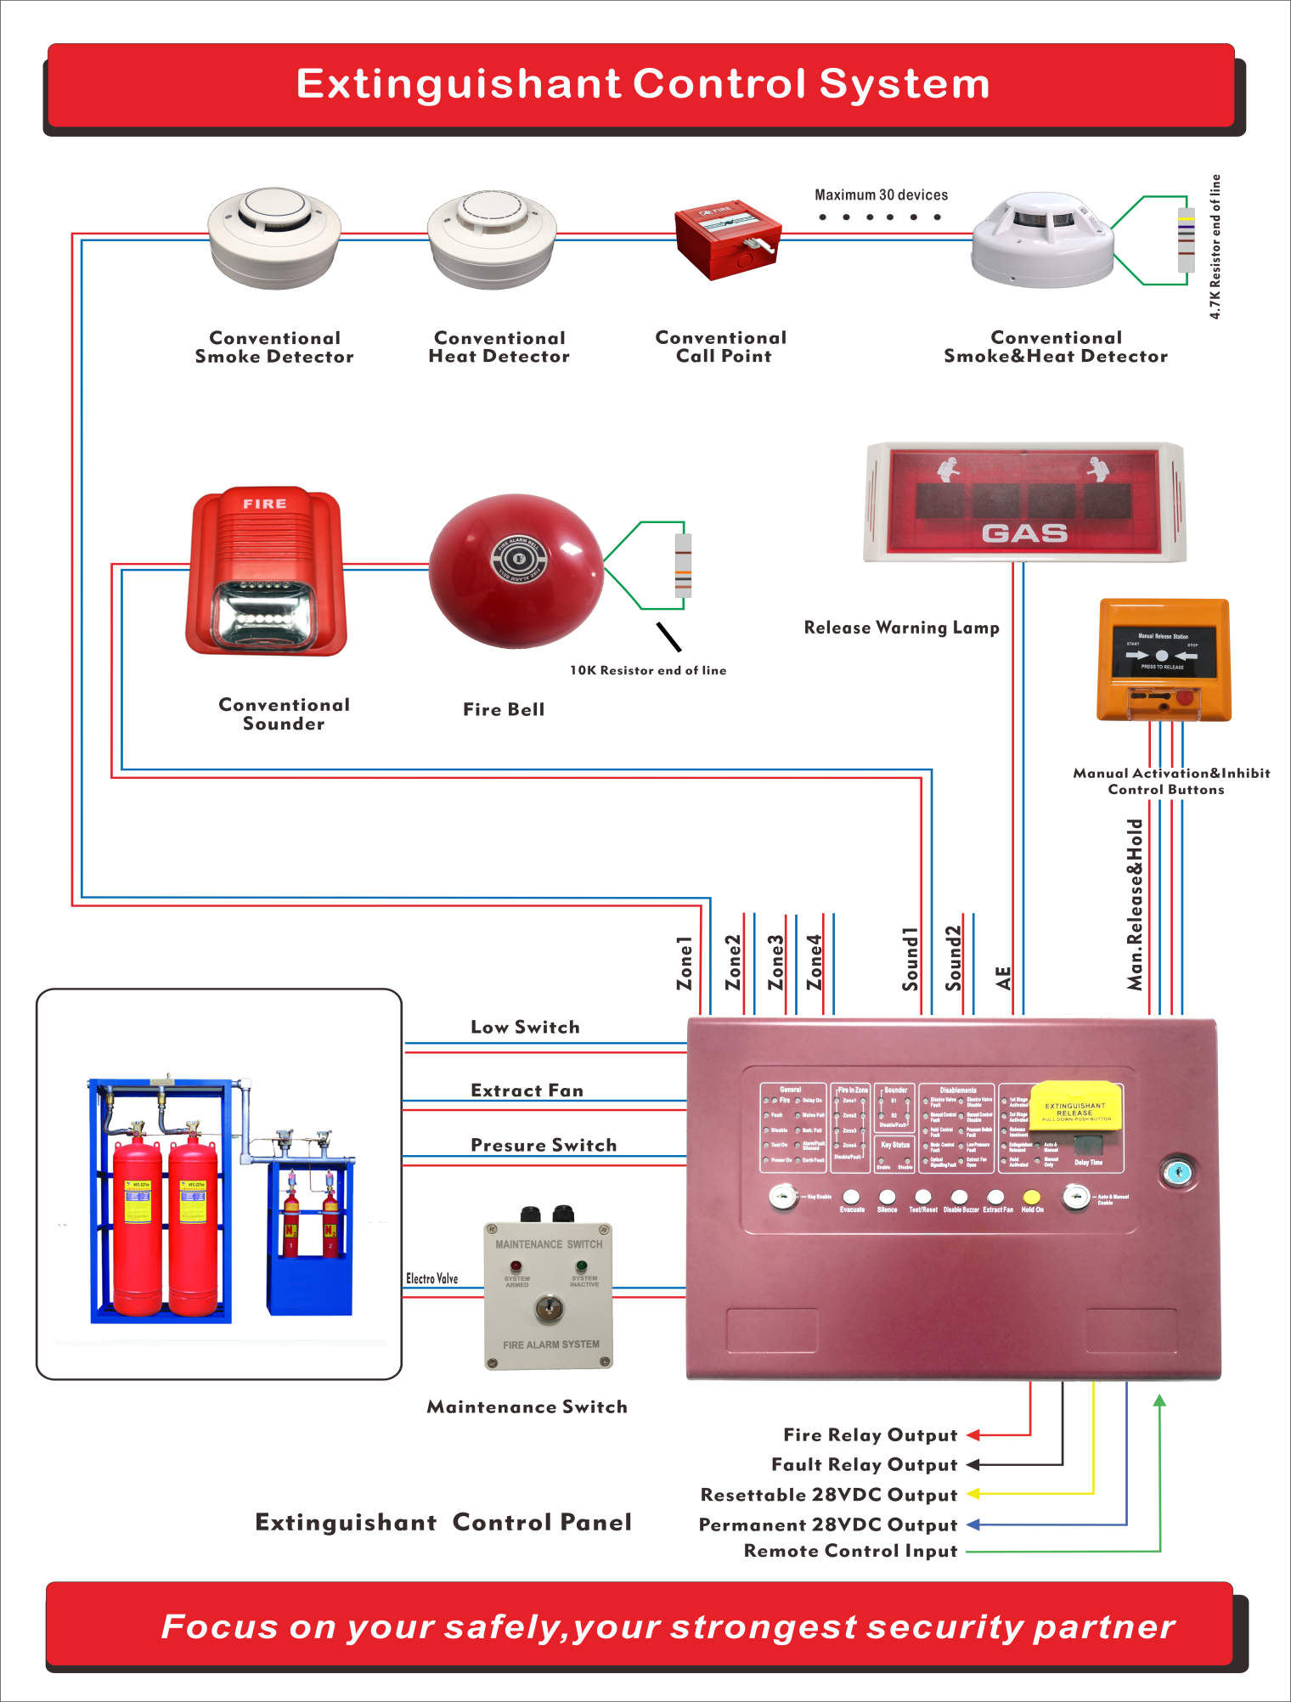

Alone Smoke Detector

Overview
To choosing this alone smoke detector equipped able to quickly detect the smoke of fires. A signal powerful sound of 85 dB is emitted to warn each member of the family,
even while they sleep.A simple solution for effective protection of your home.
It is recommended to install at least one detector per floor in the corridors leading to the living rooms.For maximum protection, put a detector per bedroom.
It is not recommended to place a device in the rooms such as kitchens and bathrooms.Locate the first alarm in the immediate area of the bedrooms but not in the bedrooms. Try to protect the exit path as the bedrooms are usually farthest from the exit.
If more than one sleeping area exists, locate additional alarms adjacent to each sleeping area.

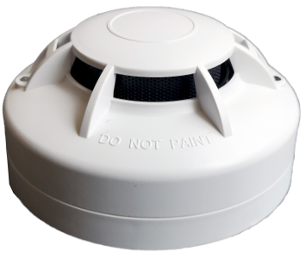

Features
※ Operating Voltage Range: 9V battery work independently
※ Standby Current:≤8µA
※ Maximum Alarm Current: ≤40mA
※ Smoke Alarm Sensitivity:0.15-0.3dB/m
※ Sound Level:85dB(A)@3M
※ Operating Temperature Range:-10°C to 50°C (14°F to 122°F)
※ Diameter：105*59 (D*H)
※ Weight:135g (With battery)

Overview
To choosing this alone smoke detector equipped able to quickly detect the smoke of fires. A signal powerful sound of 85 dB is emitted to warn each member of the family,
even while they sleep.A simple solution for effective protection of your home.
It is recommended to install at least one detector per floor in the corridors leading to the living rooms.For maximum protection, put a detector per bedroom.
It is not recommended to place a device in the rooms such as kitchens and bathrooms.Locate the first alarm in the immediate area of the bedrooms but not in the bedrooms. Try to protect the exit path as the bedrooms are usually farthest from the exit.
If more than one sleeping area exists, locate additional alarms adjacent to each sleeping area.

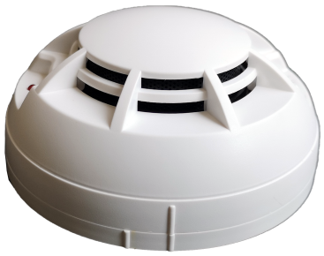

Features
※ Operating Voltage Range:DC3V battery (AA1.5V*2PCS)
※ Standby Current:≤8µA
※ Maximum Alarm Current: ≤40mA
※ Smoke Alarm Sensitivity:0.15-0.3dB/m
※ Sound Level:85dB(A)@3M
※ Operating Temperature Range:-10°C to 50°C (14°F to 122°F)
※ Diameter：105*48 (D*H)
※ Weight:132g (With battery)

Beam Detector

Overview
The detector is a conventional beam smoke detector, which must be used together with a reflector.
The number of reflector(s) to be used (one or four) depends on the distance from the detector.With excellent built-in microprocessor, the detector has trong ability of analysis and judgment. The detector can automatically carryout system adjustment, compensation of variation of ambient data, and judgment of fire and fault through fixed algorithm, and indicate these states by LED and signal output terminals. With new and reasonable design, attractive appearance, flexible adjustment and alignment method it’s easy to install and adjust.
The detector is applicable to historical buildings, warehouses, large storages, shopping malls, museums etc, as well as places where slight smoke particles exist.

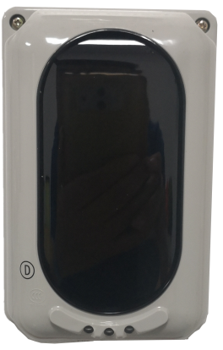

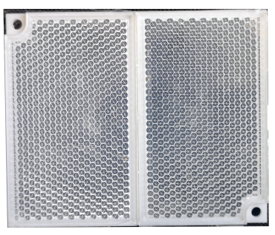

Mirror Reflector

Features
※ Operating Voltage： 20 V to 28 V DC
※ Current Parameters Standby:23mA Commission:40µA Alarm:33mA
※ Beam Sensor Sensitivity [via Encoder]： Level 1: 2.6 dB High Sensitivity
Level 2: 3.4 Medium Sensitivity
Level 3: 4.8 dB Low Sensitivity
※ Beam Pathway Length [via Encoder]: Span 1: 8 to 20 meters Short Path
Span 2: 20 to 40 meters Short Path
Span 3: 40 to 70 meters Normal Path
Span 4: 70 to 100 meters Long Path

※ Beam Path Angle ±0.5angle
※ Directional
※ Alignment Guide Laser Beam Pointer
※ Digital Display Guide Nixie Tube
※ LED Indicator Guide Red: Fire ; Yellow: Fault ; Green: Alignment
※ Reset Time Less than 2 Second
※ Relay Capacity [Fire & Fault] Normally Open/ 2.0 A; 30 VDC
※ Accessories:Mounting bracket/Mirror Reflector x4pcs
※ Physical
Material / Colour ABS / White
Dimension / Weight L:190.87 x W:126.87 x H:91.96 mm / 440 gm
Weight 0.130 Kg with base
※ Environmental
Operating Temperature Range:-10°C to 50°C (14°F to 122°F)10
Protection rating: IP30 [IP66 glue seal]
Humidity 0 to 95% Relative Humidity, Non condensing

UV Flame detectors

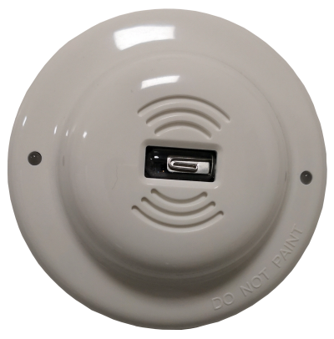
Features
※ Operating Voltage Range：12 to 28 VDC Volts
※ Standby Current：≤10 mA @ 24 VDC
※ Alarm Current：≤30 mA @ 24 VDC
※ Detection Angle：120 degree
※ Detection Sensitivity：Grade I, 25m@flame (Container 33cmX33cm,Height 5cm with 2Kg ethanol )
※ Relay Contact Load：1A@DC24V
※ Normal Status：LED blinking in 5 seconds interval
※ Alarm Status：LED lit steady
※ Protection rating：IP 21
※ Operating Humidity Range：10% to 93% Relative Humidity, Non-condensing
※ Operating Temperature Range：-20°C to 55°C
※ Height：45 mm installed in Base
※ Diameter：103 mm
※ Weight：153g

Overview
The device is an Ultraviolet-only flame detector designed to detect fires and provide alarm outputs directly from the detector while maintaining false alarm immunity. It detects in the ultraviolet (UV) spectral range for optimized speed
of response.
It is fast and capable to detecting the ultraviolet (UV) rays emitted by a burning substance and is used in high hazard applications such as petrochemical plants, munitions factories and other areas where flammable or explosive
liquids or solids are handled or stored.
The flame sensor adopts an ultraviolet photosensitive tube,
with qualities of highly sensitive, reliable, dust-resistant, corrosion proof and moisture-resistant, therefore is not sensitive in sunlight, dust, oil, tolerance of fume, and humidity.

